

FPT UNIVERSITY
Capstone Project Document
SMART MEDICINE DICTIONARY
Report #3 – User Requirement Specification
Smart Medicine Dictionary
Group Members
  Lê Thị Xuân | 01913
  Phạm Huy Khôi | 01888
  Phạm Minh Tú | 01770
  Phạm Hà Hải | 01727
  Ngô Hà Thu | 01522
Supervisor | Mr. Nguyễn Văn Sang
Project code | SMD

- Hanoi, 8/2013-
Table of Contents
3 USER REQUIREMENT SPECIFICATION 4
3.1 Introduction 4
1.1.1 Purpose 4
1.1.2 Definition and Acronyms 4
1.2 Overall description 4
3.1.1 Business process overview 4
1.3 Product features 11
1.4 User characteristics 12
1.5 Functional requirement 12
1.5.1 Registration 12
1.5.2 Pharmacy information management 12
1.5.3 Search medicine 12
1.5.4 Search pharmacy 13
1.5.5 Add new medicine 14
1.5.6 Modify medicine information 14
1.5.7 View news 14
1.5.8 News control 14
1.5.9 Medicine Usage Diary 14
1.6 Non – Functional Requirements 14
2 SYSTEM REQUIREMENT SPECIFICATION 15
2.1 Introduction 15
2.1.1 Purpose 15
2.1.2 Definition and Acronyms 15
2.1.3 Purpose of that system 15
2.2 System Features 16
2.3 Functional Specification 17
2.3.1 UC001: Search medicine on Mobile 19
2.3.2 UC002: Find the nearest pharmacy on mobile 21
2.3.3 UC003: Medical Usage Diary 23
2.3.4 UC004: Medicine Normal Search 24
2.3.5 UC005: Medicine Advance Search 26
2.3.6 UC006: Pharmacy Normal Search 28
2.3.7 UC007: Pharmacy Advanced Search 30
2.3.8 UC008: Find Nearest Pharmacy (web version) 32
2.3.9 UC009: Register 34
2.3.10 UC010: View News on web 36
2.3.11 Manage News 38
2.3.12 UC016: Login 45
2.3.13 UC017: Log out 49
2.3.14 Manage pharmacy information 51
2.3.15 Manage medicine information 57
2.3.16 Account control 69
2.4 Non-functional Specification 75
2.4.1 User interface 75
2.4.2 Hardware Requirements 76
2.4.3 Software Requirements 76
2.4.4 Reliability 77
2.4.5 Availability 78
2.4.6 Security 78
2.4.7 Maintainability 78
2.4.8 Portability 78
2.4.9 Performance 79
2.5 Entity Relationship Diagram or Data Structures 79
2.5.1 Entity Relationship Diagram 79
2.5.2 Entity Detail 80

USER REQUIREMENT SPECIFICATION

Introduction

Purpose
This document will provide the describing of general requirement and non-functional requirements of our SMD system. After reading, project team and the other people can have an overview about the user requirement specification of the system and also know more about the high level requirements of the system. This document also describes the requirement scope of each phase in the project.

Definition and Acronyms
Term | Description
SMD | Smart Medicine Dictionary
GPS | Global Positioning System
URL | Uniform Resource Locator
LOC | Line of code
Table 3-1: Definition and Acronyms

Overall description

Business process overview
SMD is not only an online dictionary about medicine but also a directory to help user find out the nearest pharmacy and the way to get there in need. Therefore, that system will implement the following processes
NOTE: The meaning of flowchart symbols:
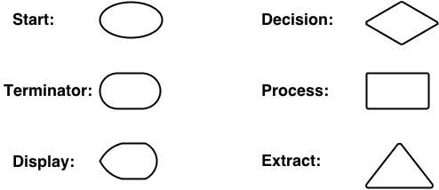

Search medicine process workflow
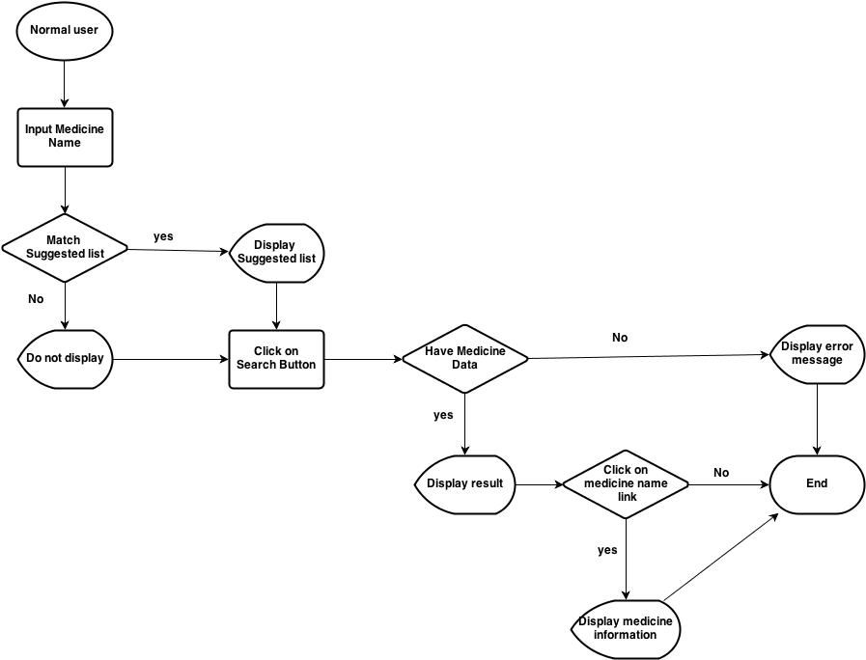
Figure 3-1: Search medicine process workflow

Brief description: Everyone can do that search process. It is divided into these steps:
Step 1: User inputs medicine name (or information of that medicine) into text box. System has auto-complete feature, therefore, system will list all suggested medicine name that match to what user inserts
Step 2: After user click on search button, system will filter from database to find out if that medicine name exist. If it does not exist, system will display error message to inform that data not found. If it exists, system will display result
Step 3: User can click on medicine name on table result to see information detail of that medicine

Find nearest pharmacy workflow on web module:
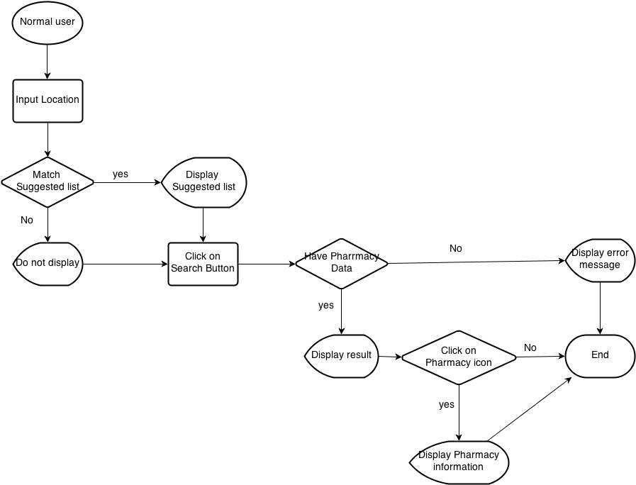
Figure 3-2: Find nearest pharmacy workflow on web module

Brief description: Find the nearest pharmacy can also be used by every user.
Step 1: User input location name into text box. System has auto-complete feature, therefore, system will list all suggested medicines' name that match to what user input
Step 2: After user click on Search button, system will filter to find out which pharmacy has address around that place. If there is no registered pharmacy there, system will display “data not found” message then end process. If system can find pharmacies there, it will display them on google map as location icon
Step 3: User can click on one pharmacy icon on Google map to see that pharmacy detail information

Find nearest pharmacy workflow on mobile
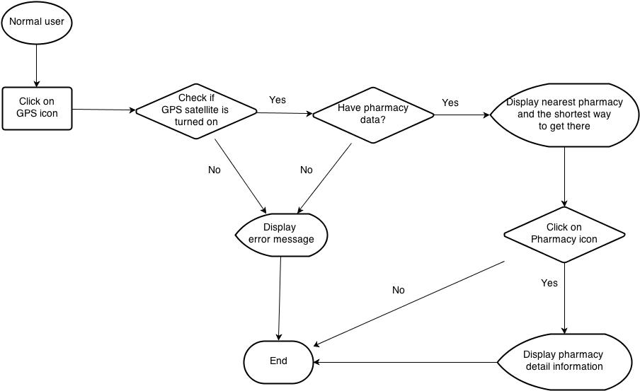
Figure 3-3: Find nearest pharmacy workflow on mobile

Brief description: Find the nearest pharmacy can also be used by every user
Step 1: To access to that feature on mobile version, after access to that software, user must click on GPS icon. System will access to GPS satellite of their mobile device to find the nearest pharmacy around their location
Step 2: System will show the shortest way from their location to the nearest pharmacy. User can click on that pharmacy icon to see that pharmacy detail information

Medical Usage Diary workflow

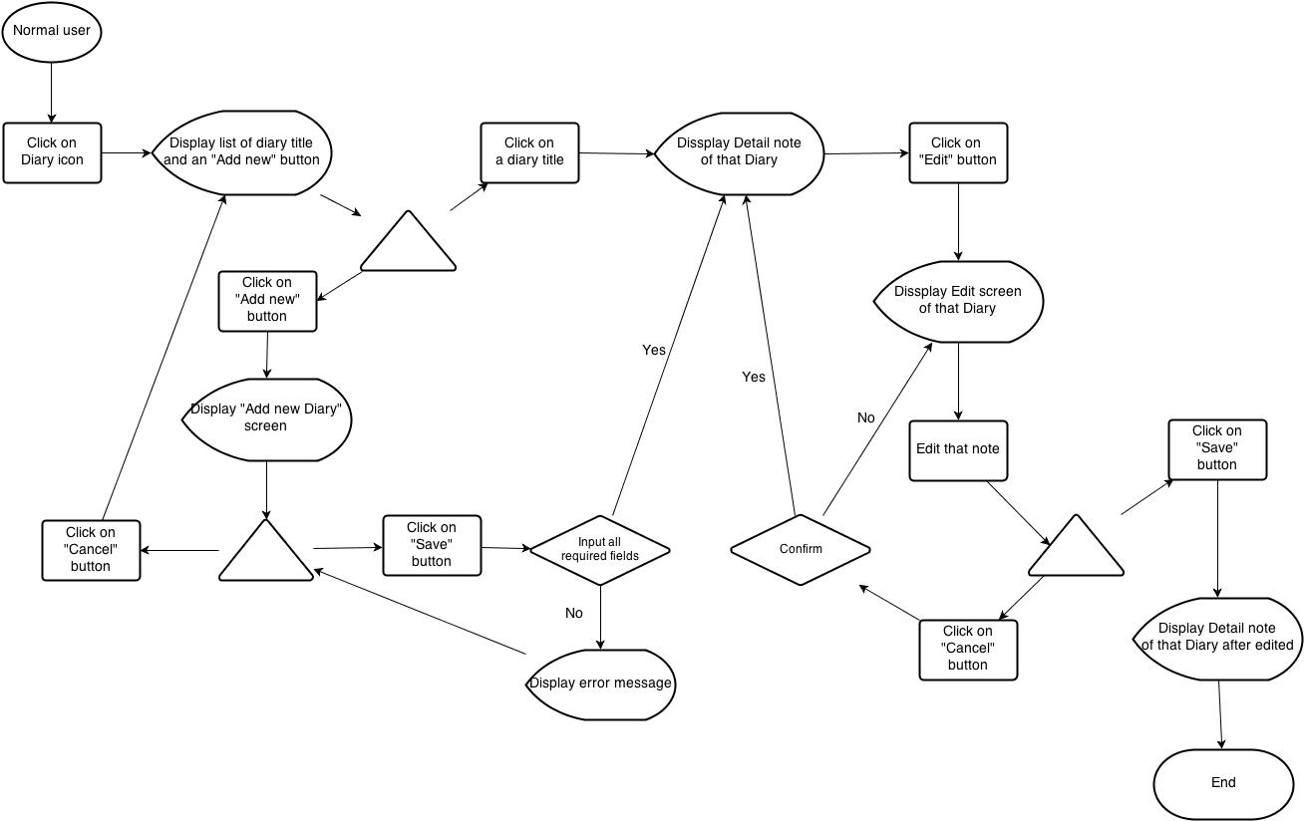
Figure 3-4: Medical Usage Diary workflow

Brief description: Medical diary can also be used by every user who use mobile version
Step 1: User click on Diary icon after access to that software on their mobile device. System display a list of Diary that has been added and an “Add new” button
Step 2: User click on one Diary title on that list. System will display detail note of that Diary with Edit button on the bottom of screen
Step 3: After user click on Edit button, system will display Diary Edit screen. User can amend their note then press “Save” button to save edited data. If not, system will return to detail note screen
Step 4: User can click on “Add new” button on main Diary screen. System will display Add new diary screen. User can click cancel to back to main Diary screen or fill their note then click “Save” button to save their new note and switch to detail note of that diary

Add new and modify workflow
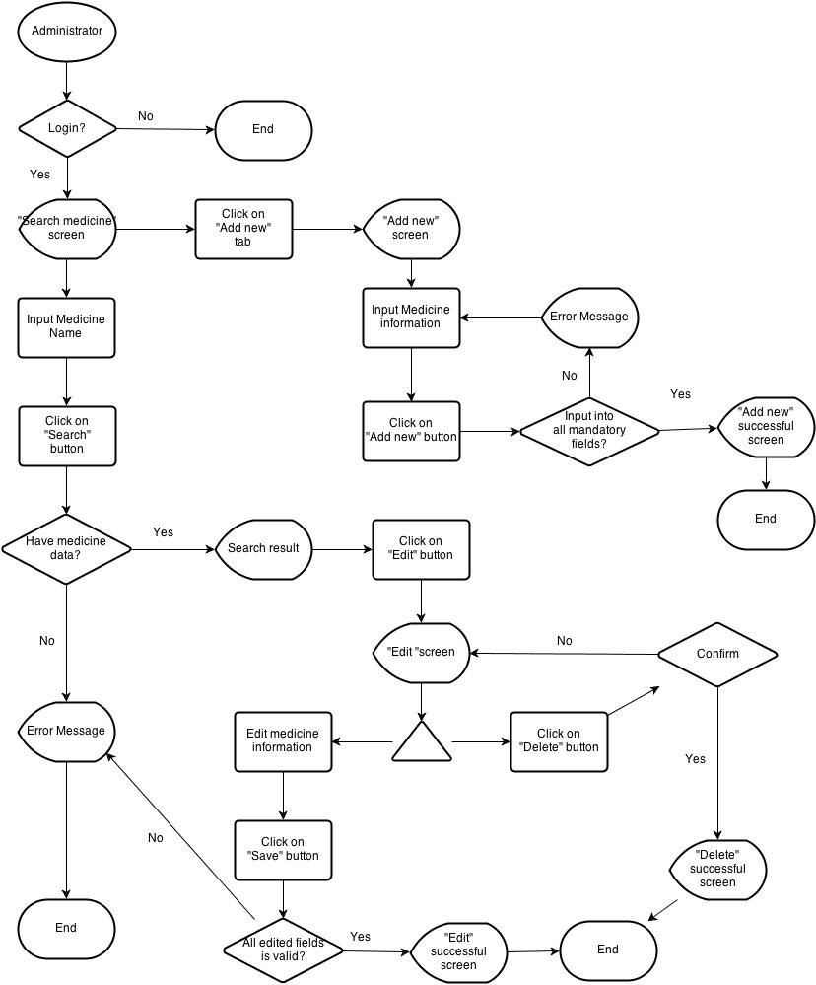
Figure 3-5: Add new and modify workflow

Brief description: Only administrator can add new or modify information of medicine and pharmacy.
Step 1: System will check if user have logged in as administrator. If the answer is “yes”, system will display “Add new” tab on submenu
Step 2: After user click on “Add new” tab, system will display Add new screen
Step 3: Administrator must insert all necessary information into all fields then click on “Add new” button. System will check if all fields are validated. Then it will display Successful screen if all fields are valid. If not, return error message
Step 4: Administrator click on Search tab on submenu. Insert medicine or pharmacy name then click Search button. System displays result if data can be found
Step 5: Administrator click on Edit button beside medicine (pharmacy) name. System display medicine (pharmacy) information
Step 6: Administrator amend the information that have to be changed then click “Save” button. System will check the validation of amended information. If it is ok, system will display successful screen
Step 7: After accessing into Edit screen, user can also click on “Delete” button on the bottom of that screen to delete that medicine (pharmacy) information

Register workflow
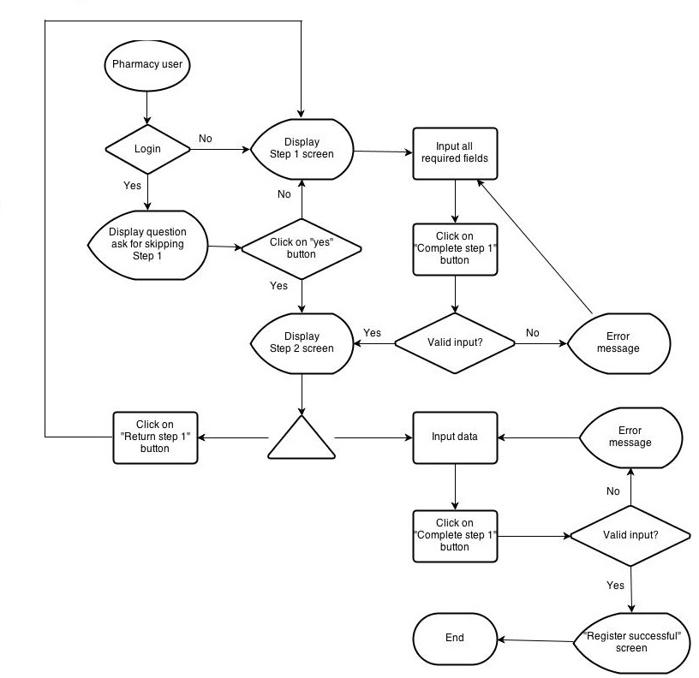
Figure 3-6: Register workflow
Brief description:
Step 1: System will check if user have logged in system. If user have already logged into that system, system will display question to ask if they continue with their registered information then skip to step 2
Step 2: If user choose “yes”, system will skip to step 2 and use their information to auto fill into step 1 screen. If not, continue with step 1 screen
Step 3: User insert into all required fields then click on “Complete step 1” button. System will check the validation of all inserted fields. If it is invalid, display error message beside wrong fields. If ok, continue with step 2 screen
Step 4: On Step 2 screen, user can choose to return to step 1 to amend information or continue to insert all required data on that screen. After user click on “Complete process” button, system will check the validation of all inserted fields. If it is invalid, display error message beside wrong fields. If ok, system will display success screen

Product features
SMD is an online system that can run in both web application and Android devices so it is flexible and convenient to use every time and everywhere that can connect to the internet. The system is divided into multiple modules for each specific kind of user. The combination of these modules makes the workflow of the whole system become unified, so that it can work fluently
- On web module, that system provides these main functions:
  - Manage medicine information
System just allows user who logins as Administrator have permission to manage medicine information. So that they can search/ add new/ edit/ delete/ restore medicine information as they want.
With normal user, they only have permission in add new medicine into the selling list of their pharmacy
  - Manage pharmacy information
Administrator user will also have permission to manage pharmacy information. They can accept or reject or delete every pharmacies information which has problem
Normal user can only apply their own pharmacy into system after being accepted by admin
  - Search medicine
Everyone who uses that system can make search with medicine information.
  - Search pharmacy
Everyone who uses that system can make search with pharmacy information.
  - Find the nearest pharmacy
Everyone who uses that system can easily find out the pharmacy that is near by their location by input their position
  - View news
Everyone who uses that system can up to date with medical information through that software
- Mobile module has these main functions:
  - Search medicine
Everyone who uses that system can make search with medicine or pharmacy information.
  - Find the nearest pharmacy
Everyone who uses that system can easily find out the pharmacy that is near by their location by accessing their mobile GPS satellite
  - Diary
This feature just runs on mobile version. User can save their medicine taking schedule to be alarmed on time

User characteristics
There are three main actors that system support:
- Visitor: Do not have account on system. In general, they should be people who need to search for medicine or pharmacy or they could also people who have few properties and want a fast look up, in short time, a limitation of steps and without registration.
- Pharmacy User: Have account on system, they might be pharmacist who has their pharmacy access to our system
- Administrator: The full power user of the system who has all functions of normal user and has an Administrator control panel to manage all configuration of system.

Functional requirement

Registration
Access right: Pharmacy user
That function displays only on web version and it is used only for pharmacist to subscribe website for their pharmacy. They can access registration form from Pharmacy/ Register submenu.
To register, they have to fill all necessary information such as: Pharmacist name, Pharmacy name, Address, Practicing Certificate number, Business License, Phone number…

Pharmacy information management
Access right: Administrator
That function displays only on web version and it is used only for Administrator user. User can only be registered successfully after being accepted by Admin. If Administrator find out a pharmacy that has problem or violate some rule, they can reject or delete it from system

Search medicine

Quick Search
Access right: Visitor
The system shall provide facilities on both web and Android smart phone for user to search medicine information by medicine name.
- On web version, this function displays as a bar under sub menu in homepage. User can make a quick search directly from homepage.
- On mobile version, there is only quick search feature. User can access it by tapping on search icon.

Advanced Search
Access right: Visitor
User can access that function in Medicine/ Advanced Search submenu. This function provides user more option to make search result more precise. It is extremely effective for user who knows exactly what they want to know. They can search by these options:
- Medicine name
- Contraindicated
- Main ingredient
- Manufacture
- Package

Search pharmacy

Quick Search
Access right: Visitor
The system shall provide facilities on both web and Android smart phone for user to search pharmacy information by pharmacy name.
- On web module, this function displays as a bar under sub menu in homepage. User can make a quick search directly from homepage.
- On mobile module, there is only quick search feature. User can access it by tapping on search icon.

Advanced Search
Access right: Visitor
User can access that function in Pharmacy/ Advanced Search submenu. This function provides user more option to make search result more precise. It is extremely effective for user who knows exactly what they want to know. They can search by these options:
- Pharmacy name
- Representative name
- Address
- GPP

Add new medicine
Access right: Administrator and Pharmacy user
That function displays only on web version. Administrator can access that function in Medicine/ Add new on submenu. With register user, they can add new medicine if their selling medicine does not exist in system.

Modify medicine information
Access right: Administrator
That function displays only on web version and it is used only for Admin. They have full permissions on edit/ delete/ restore medicine information as they want.

View news
Access right: Visitor
That feature will collect information from some trustful medical page and update daily to help user be kept up with medical information

News control
Access right: Administrator
The administrator will browse the medical news daily then handling update News part by add, edit, delete news feature of the system

Medicine Usage Diary
Access right: Visitor
This feature just runs on mobile version. User can save their medicine taking schedule on their mobile to be alarmed on time

Non – Functional Requirements
- Easy to maintain and upgrade
- Ensure data security capabilities, high performance
- GUI is clear, friendly and easy to use.
- System has clear permission for user and can support for user with multi roles.

SYSTEM REQUIREMENT SPECIFICATION

Introduction

Purpose
This document will provide the describing of general requirement and non-functional requirements of our SMD system. After reading, project team and the other people can have an overview about the user requirement specification of the system and also know more about the high level requirements of the system. This document also describes the requirement scope of each phase in the project.

Definition and Acronyms
Term | Description
SMD | Smart Medicine Dictionary
GPS | Global Positioning System
URL | Uniform Resource Locator
LOC | Line of code
Table 3-1: Definition and Acronyms

Purpose of that system
That system is developed to help two kind of objective users: everyone who cares about medical and pharmacy
- The first purpose of that system is to help users easily find out information about one kind of medicine or pharmacy which they want to know more
- The second purpose is to be a promotion channel for pharmacies. That software can bring pharmacies to be nearer to users

System Features
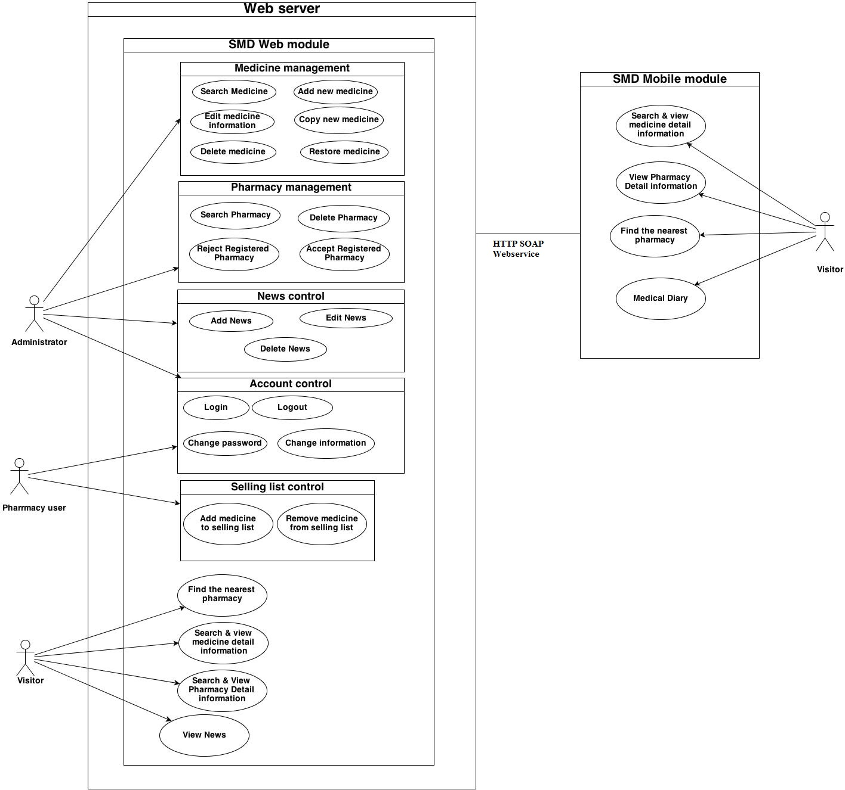
Figure 4-1: System Overview

Use Case No. | Group of functions | Functions | Glossary
Mobile module
 | Search Medicine | Normal search | Tìm kiếm thuốc
 | Search Medicine | Medicine detail | Thông tin thuốc
 | Search Pharmacy | Normal search | Tìm kiếm nhà thuốc
 | Search Pharmacy | Pharmacy detail | Thông tin nhà thuốc
 | Search Pharmacy | Medicine selling | Danh sách thuốc
 |  | Find the nearest pharmacy | Tìm nhà thuốc gần nhất
 |  | Medical Diary | Nhật ký
Web module
 | Search medicine | MedicineNormal search | Tìm kiếm thuốc
 | Search medicine | Medicine advanced search | Tìm kiếm thuốc nâng cao
 | Search pharmacy | Pharmacy Normal search | Tìm kiếm nhà thuốc
 | Search pharmacy | Pharmacy advanced search | Tìm kiếm nhà thuốc nâng cao
 | Search pharmacy | Find the nearest pharmacy | Tìm nhà thuốc gần nhất
 | News | View News | Tin tức
 | News | Search News | Tìm kiếm tin tức
 | News | Add News | Thêm mới tin tức
 | News | Edit News | Chỉnh sửa tin tức
 | News | Delete News | Xóa tin tức
 | News | Restore News | Khôi phục
 | Account control | Register | Đăng ký
 | Account control | Login | Đăng nhập
 | Account control | Logout | Đăng xuất
 | Account control | <Pharmacy user> Change information | Thay đổi thông tin
 | Account control | <Pharmacy user> Change password | Thay đổi mật khẩu
 | Account control | <Pharmacy user> Add new selling medicine | Danh sách thuốc có bán
 | Manage pharmacy information | Search registered pharmacy | Tìm kiếm nhà thuốc đã đăng ký
 | Manage pharmacy information | Accept registered pharmacy | Chấp nhận nhà thuốc đăng ký
 | Manage pharmacy information | Delete pharmacy | Xóa bỏ nhà thuốc
 | Manage medicine information | Search medicine | Tìm kiếm thuốc
 | Manage medicine information | Add new medicine | Thêm mới thuốc
 | Manage medicine information | Copy new medicine | Bản sao thuốc mới
 | Manage medicine information | Edit medicine | Chỉnh sửa thông tin thuốc
 | Manage medicine information | Delete medicine | Xóa bỏ thuốc
 | Manage medicine information | Restore medicine | Khôi phục thuốc

Functional Specification
On mobile module, user no need to sign in system, therefore, all features can be used by everyone. However, on web module, use roles are clearly separated for each features as the below table:

No | Use Case | Visitor | Administrator | Pharmacy User
 | Web Module
 | Medicine normal search | x | x | x
 | Medicine advance search | x | x | x
 | Pharmacy normal search
 | Pharmacy advance search | x | x | x
 | Find the nearest pharmacy | x | x | x
 | View News | x | x | x
 | Search News |  | x
 | Add News |  | x
 | Edit News |  | x
 | Delete News |  | x
 | Restore News |  | x
 | Register |  | x
 | <Admin> Login |  | x
 | <Admin> Logout |  | x
 | <Admin> Search registered pharmacy |  | x
 | <Admin> Accept registered pharmacy |  | x
 | <Admin> Delete pharmacy |  | x
 | <Admin> Search medicine |  | x
 | <Admin> Add new medicine |  | x
 | <Admin> Copy new medicine |  | x
 | <Admin> Edit medicine |  | x
 | <Admin> Delete medicine |  | x
 | <Admin> Restore medicine |  | x
 | <Pharmacy user> Login |  |  | x
 | <Pharmacy user> Logout |  |  | x
 | <Pharmacy user> Change information |  |  | x
 | <Pharmacy user> Change password |  |  | x
 | <Pharmacy user> Add new selling medicine |  |  | x
Table 2-2: Table of user’s decent ration

UC001: Search medicine on Mobile

Use Case Diagram
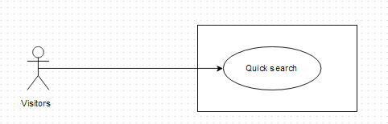

Use-Case Specification

UC001 - Specification
Use-case No. | <UC001> | Use-case Version |  | <1.0>
Use-case Name | Search medicine (mobile version)
Author | Thu NH
Date | 22/05/2013 | Priority | Normal
Actor:
Visitor, Pharmacy users, Administrator
Summary:
This is one of the main features of that software. On mobile version, user can easily make a quick search to find out information about the medicine they concern by its name everywhere that can connect to the internet
Preconditions:
Users have to install that software on their Android devices and it is connecting to the internet
Post Conditions:
System displays medicine detail information
Main Success Scenario:
Step | User | System
1 | Click on that software icon on mobile | Displays home page
2 | Click on “Quick Search” tab or Search icon below the screen | Displays search screen including
2 | Type medicine name into search box on home page
3 | Click “Search” button | Display result on the search screen
4 | Click on a medicine name | Displays medicine detail information

Alternative flows:
At Step | User | System
3 | Click “Search” button | If there is not any medicine matched with the user's input, the system displays an warning message to inform that data not found

Business rule:
- User cannot insert more than 100 characters into medicine name text box
- Can only query by medicine name

UC002: Find the nearest pharmacy on mobile

Use Case Diagram

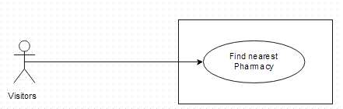

Use-case Specification

UC002 - Specification
Use-case No. | <UC002> | Use-case Version |  | <1.0>
Use-case Name | Find nearest pharmacy (mobile version)
Author | Thu NH
Date | 22/05/2013 | Priority | <High >
Actor:
Visitor, Pharmacy users, Administrator
Summary:
This is one of the main feature of system. Users only need to insert their location into text box, then press search. All registered pharmacy around their location will display on map with the nearest one is highlighted. Look at the map, users can easily find out the way to get there.
Triggers
Users have to install that software in their Android devices and Location Access feature on mobile has been turned on and user clicks on “Find the nearest pharmacy” tab on Home screen
Preconditions:
Users have to install that software in their Android devices and Location Access feature on mobile has been turned on
Post Conditions:
System displays the nearest pharmacies around user place on map
Main Success Scenario:
Step | User | System
1 | Click on “Find Nearest Pharmacy” tab on the Home screen | Access their location by GPS satellite of their mobile then display nearest pharmacy around their place on map
2 | Click on the nearest pharmacy icon on map | Show that pharmacy information and the direction to get there
3 | Typing their location on “Location” text box | Displays nearest pharmacy around the inserted place on map
4 | Click on the nearest pharmacy icon on map | Show that pharmacy information and the direction to get there

Alternative flows:
At Step | User | System
1 | Click on “Find Nearest Pharmacy” tab | if “Location access” feature is turned off, the system shows Location text box blank.
2 | Insert their location on “Location” text box in screen right corner | Displays nearest pharmacy around the inserted place on map
Business rule:
- Cannot input more than 100 characters into Location text box
- Just access location in Vietnam

UC003: Medical Usage Diary

Use Case Diagram

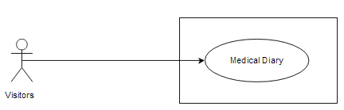

Use-case Specification

UC003 - Specification
Use-case No. | <UC003> | Use-case Version |  | <1.0>
Use-case Name | Medical Usage diary
Author | Thu NH
Date | 22/05/2013 | Priority | <High >
Actor:
Visitor, Pharmacy users, Administrator who uses that software on Android devices
Summary:
User can use their device as an alarm to take medicine in time or to take note which kinds of medicine they have to use
Triggers
Home screen is displayed with available "Medical Diary" tab and user clicks on “Medical Diary” tab on the Home screen
Preconditions:
Users have installed that software on their device and Home screen is displayed with available "Medical Diary" tab.
Post Conditions:
System must alarm user in time
Main Success Scenario:
Step | User | System
1 | Click on “Medical Diary” tab on Home screen | Displays Medical diary page with Add new button and list of saved notes
2 | Click on Add new button | Displays “New note” screen with these fields:  - “Subject” text box  - “Medical list” text box  - “Start” text box  - “End” text box  - “Save” button  - “Cancel” button
3 | Fill all fields
4 | Click on “Save” button on "New Note" screen | a. The system validates the input data and then save data into database  b. Displays detail note for each medicine with taking medicine time and dosage then system will automatically alarm user

Exceptions:
At Step | User | System
4 | Click on “Cancel” button | These text box will be blank

UC004: Medicine Normal Search

Use Case Diagram

Use-case Specification

UC004 - Specification
Use-case No. | <UC004> | Use-case Version |  | <1.0>
Use-case Name | Medicine Normal Search (web version)
Author | Thu NH
Date | 22/05/2013 | Priority | High
Actor:
Visitor, Pharmacy users, Administrator
Summary:
This is one of the main features of that software. User can make a quick search to find out information about the medicine they concern by its name right after entering to website
Goal:
Search for medicine by its name directly from home page
Preconditions:
The Home page (quick search medicine) screen is displayed
Trigger:
The Home page is displayed, the medicine name is entered and Search button is clicked.
Post Conditions:
System displays medicine detail information
Main Success Scenario:
Step | User | System
1 | Type medicine name into search box on Home page | Auto-complete feature will check and gives suggested list bases on characters that user input
2 | Click “Search” button | Display result- the list of found medicine
3 | Click on a medicine name | Displays medicine detail information
Alternative Scenarios:
At Step | User | System
3 | Click on other link on screen Search Screen | Switch to selected page

Exception:
At Step | User | System
3 | Click “Search” button but medicine does not exist in the database | Return warning message to inform that data not found

Business rule:
- Quick search can only query by medicine name
- User cannot input more than 100 characters into text box

UC005: Medicine Advance Search

Use Case Diagram

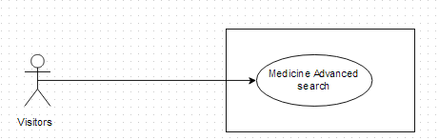

Use-case Specification

UC005 - Specification
Use-case No. | <UC005> | Use-case Version |  | <1.0>
Use-case Name | Medicine Advanced Search
Author | Thu NH
Date | 22/05/2013 | Priority | <High>
Actor:
Visitor, Pharmacy users, Administrator
Summary:
This is the main function of that system. People have many choices to find out the medicine they concern such as: Medicine name, Contraindicated, Main ingredient, Manufacture, Package
Goal:
To search for medicine information
Triggers
User click on “Advance search” hyperlink right below “Search” button on Home screen to access “Medicine advanced search” screen. User must input information into the right fields then click “Search” button
Preconditions:
The information that user has input must be correctly
Post Conditions:
Search medicine must have data information in database
Main Success Scenario:
Step | User | System
2 | Click on “Medicine/ Medicine Advanced Search” hyperlink on Search Medicine screen | Switch into Advance search page
3 | Type the element that they want to filter result by into the right text box
4 | Click “Search” button | Displays result on the current screen.
5 | Click on medicine name on the search result | Displays medicine detail information
Alternative Scenario:
At Step | User | System
4 | Click another link | Switch to selected page
Exceptions:
At Step | User | System
3 | Type the element that they want to filter result by into the right text box (No medicine in database matches these elements)
4 | Click “Search” button | Return warning message to inform that cannot find matching medicine

UC006: Pharmacy Normal Search

Use Case Diagram

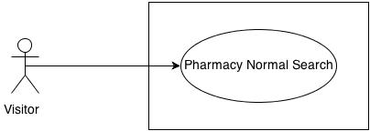

Use-case Specification

UC006 - Specification
Use-case No. | <UC006> | Use-case Version |  | <1.0>
Use-case Name | Pharmacy Normal Search
Author | Thu NH
Date | 22/05/2013 | Priority | <High >
Actor:
Visitor, Pharmacy users, Administrator
Summary:
With that feature, user can input the element that they have known such as: Brand name, main ingredient, package… into the right element text box on search criteria screen. Basing on what user has input, system will query and find out the appropriate medicine
Goal:
Users can find out list of pharmacies that follows their criteria
Triggers
User click on “Pharmacy Search” tab on submenu. After input pharmacy name into text box, user must click “Search” button
Preconditions:
The information that user has input must be correctly
Post Conditions:
System can find out and display detail information of pharmacy which has matched search criteria.
Main Success Scenario:
Step | User | System
2 | Click on “Pharmacy Search” tab on menu | Displays “Pharmacy Search” with text box to make quick search pharmacy by pharmacy’s name on the current screen.
3 | Type pharmacy name into text box then press “Search” button | Displays list of pharmacies that match these criteria
4 | Click on pharmacy name | Show that pharmacy information

Exceptions:
At Step | User | System
4 | Insert name of an unregistered into text box then press Search button | Return warning message that cannot find data
Business rule: System can only find out pharmacy that has been accepted

UC007: Pharmacy Advanced Search

Use Case Diagram

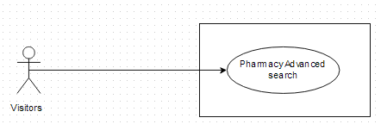

Use-case Specification

UC007 - Specification
Use-case No. | <UC007> | Use-case Version |  | <1.0>
Use-case Name | Pharmacy Advanced Search
Author | Thu NH
Date | 22/05/2013 | Priority | <High >
Actor:
Visitor, Pharmacy users, Administrator
Summary:
With that feature, user can input the element that they have known such as: Brand name, main ingredient, package… into the right element text box on search criteria screen. Basing on what user has input, system will query and find out the appropriate medicine
Goal:
Users can find out list of pharmacies that follows their criteria
Triggers
User click on “Pharmacy Search” tab on submenu. Click on “Advanced search” hyperlink below “Search” button. After input information into the right fields, user must click “Search” button
Preconditions:
The information that user has input must be correctly
Post Conditions:
System can find out and display detail information of pharmacy which has matched search criteria.
Main Success Scenario:
Step | User | System
1 | Click on “Pharmacy Search” tab on menu | Display “Pharmacy normal search” screen
2 | Click on “Pharmacy Advance Search” link beside “Search” button on Search Pharmacy screen | Displays “Search Criteria” screen with these element:  - Pharmacy name  - Address  - Medicine in store  - GPP
3 | Insert the criteria they want to filter by into text box then click “Search” button | Displays list of pharmacies that match these criteria
4 | Click on pharmacy name | Show that pharmacy information on the Pharmacy Details screen

Exceptions:
At Step | User | System
3 | Insert the criteria they want to filter by into text box (No pharmacy match these criteria) then press Search button | Return warning message that cannot find data
Business rule: System can only find out pharmacy that has been accepted

UC008: Find Nearest Pharmacy (web version)

Use Case Diagram

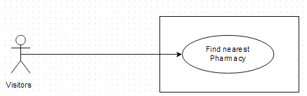

Use-case Specification

UC008 - Specification
Use-case No. | <UC008> | Use-case Version |  | <1.0>
Use-case Name | Find Nearest Pharmacy
Author | Thu NH
Date | 22/05/2013 | Priority | <High >
Actor:
Visitor, Pharmacy users, Administrator
Summary:
This is one of the main feature of system. Users only need to insert their location into text box, then press search. All registered pharmacy around their location will display on map with the nearest one is highlighted. Look at the map, users can easily find out the way to get there.
Goal:
To find the nearest pharmacy around your area or at the location that you want to know
Triggers
User click on “Find Nearest Pharmacy” tab on submenu. User must input the right location into “location” text box on “Find nearest pharmacy” screen then click “Search” button
Preconditions:
The input location must be in Vietnam
Post Conditions:
System still connect to the internet. There must be registered pharmacy at the input location
Main Success Scenario:
Step | User | System
1 | Click on “Find Nearest Pharmacy” tab | Displays “Find nearest pharmacy” with the text box and search button
2 | Insert their location address into text box then press Search button | Displays nearest pharmacy around their place on map
3 | Click on the nearest pharmacy icon on map | Show that pharmacy information and the direction to get there

Exceptions:
At Step | User | System
3 | Insert location address that do not exist into text box then press Search button | Return error message

Business rule:
- User cannot input more than 250 characters into “Location” text box
- Only display accepted pharmacy

UC009: Register

Use Case Diagram
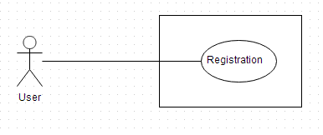

Use-case Specification

UC009 - Specification
Use-case No. | <UC009> | Use-case Version |  | <1.0>
Use-case Name | Register
Author | Thu NH
Date | 22/05/2013 | Priority | <High >
Actor:
Pharmacist, who want to use that software for their pharmacies
Summary:
Visitor who has pharmacy can create an account to control and public their pharmacy information on that software for another users and visitors know about them. To create account, user must get through 2 steps: insert representative information and insert pharmacy information
Goal:
Register an account for representative of a pharmacy
Triggers
User click on “Register” tab on submenu. User must have all necessary information of at least one pharmacy to register. After fill all fields of 2 steps, user must click “Complete register” button
Preconditions:
All mandatory fields must be filled
Post Conditions:
User registers successfully
Main Success Scenario:
Step | User | System
1 | Click on “Register” tab on submenu | Displays register form
2 | Fill all necessary and mandatory information | The system validates the input data
3 | Click “Register” button | - The system validates the input data and then save data into database  - Go to successful page to inform that user have to confirm it in their email

Alternative Scenario:
At Step | User | System
2 | Fill all necessary and mandatory information then click on other feature | Close form and redirect to direct page

Exceptions:
At Step | User | System
2 | Insert incorrect information or keep mandatory field blank
3 | Click “Register” button | Displays Error message beside wrong fields
Business rule:
- User has to input address information as the order: City, District, Street/Village, Number/ Lane
- Password must be longer than 8 characters
- Mobile number must be longer than 10 numbers

UC010: View News on web

Use Case Diagram
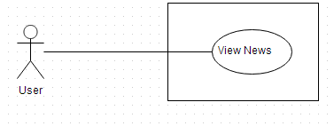

Use-case Specification

UC010 – Specification
Use-case No. | <UC0010> | Use-case Version |  | <1.0>
Use-case Name | View news
Author | Thu NH
Date | 22/05/2013 | Priority | <High >
Actor:
Visitor, Pharmacy users, Administrator
Summary:
System also supplies medical news to help user be kept up with the newest information about medical. User can view short medical news on News screen of SMD website
Goal:
User can up to date medical news directory from that software
Triggers
User click on “News” tab on submenu then click on one headline to see the detail of that article
Preconditions:
System still connect to the internet
Post conditions:
System can display the article in detail
Main Success Scenario:
Step | User | System
1 | Click on News tab | Displays News screen with some short headline of daily news
2 | Clicks on one headline | Shows that article in detail

Manage News

Use Case Diagram
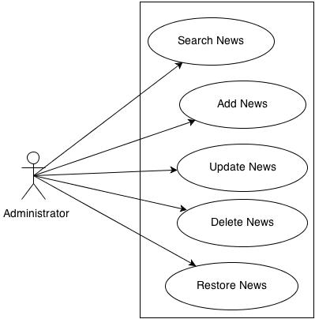

Use-case Specification

UC0011: Search News

UC0011 – Specification
Use-case No. | <UC0011> | Use-case Version |  | <1.0>
Use-case Name | Search news
Author | Thu NH
Date | 22/05/2013 | Priority | <High >
Actor:
Administrator
Summary:
System also supplies medical news to help user be kept up with the newest information about medical. Administrator user can search the list of News to control it
Goal:
Administrator can search for the News list
Triggers
Administrator click on “Manage News” tab on submenu. User click on “Search News” tab and can input News information into search criteria then click on “Search” button
Preconditions:
Input data must be right and it is input into the corrected fields
Post conditions:
System can display list of news on search result
Main Success Scenario:
Step | User | System
1 | Click on “Manage News/ Search News” tab | Displays Search News screen
2 | Input data into Search criteria text boxes
3 | Click on “Search” button | Display the list of corresponding News on search result

UC0012: Add News

UC0012 – Specification
Use-case No. | <UC0012> | Use-case Version |  | <1.0>
Use-case Name | Add news
Author | Thu NH
Date | 22/05/2013 | Priority | <High >
Actor:
Administrator
Summary:
System also supplies medical news to help user be kept up with the newest information about medical. Administrator user can add medical News into system
Goal:
Administrator can add news article to display on News screen successfully
Triggers
Administrator click on “Manage News/Add news” tab on submenu. Admin input data into all mandatory field then click “Save” button
Preconditions:
Input data must be right and it is input into the corrected fields
Post conditions:
System can save new news and display it on News screen
Main Success Scenario:
Step | User | System
1 | Click on “Manage News/ Add News” tab | Displays “Add News” screen
2 | Input data into the correct text boxes
3 | Click on “Save” button | Save news and display it on News screen

UC0013: Update News

UC0013 – Specification
Use-case No. | <UC0013> | Use-case Version |  | <1.0>
Use-case Name | Update News
Author | Thu NH
Date | 22/05/2013 | Priority | <High >
Actor:
Administrator
Summary:
System also supplies medical news to help user be kept up with the newest information about medical. To be sure that the information which is provided to customer is the best Administrator user can update medical News if it has some problem
Goal:
Administrator can update news article to display on News screen successfully
Triggers
Administrator click on “Manage News/Search news” tab on submenu. After find out the news that needs to be edited, admin can click into that article. They can amend data in mandatory field then click “Save” button
Preconditions:
Input data must be right and it is input into the corrected fields
Post conditions:
System can save updated news and display it on News screen
Main Success Scenario:
Step | User | System
1 | Click on “Manage News/ Search News” tab | Displays “Search News” screen
2 | Search for the news that needs to be edited | Displays list of corresponding news on search result
3 | Click into that article | Display “Update News” screen
4 | Amend its data in the correct text boxes | Validate the input
5 | Click on “Save” button | Save news and display it on News screen

UC0014: Delete News

UC0014 – Specification
Use-case No. | <UC0014> | Use-case Version |  | <1.0>
Use-case Name | Delete news
Author | Thu NH
Date | 22/05/2013 | Priority | <High >
Actor:
Administrator
Summary:
System also supplies medical news to help user be kept up with the newest information about medical. To be sure that the information which is provided to customer is the best Administrator user can delete medical News if it has some problem
Goal:
Administrator can delete news successfully
Triggers
Administrator click on “Manage News” tab on submenu. User click on “Search News” tab and can input News information into search criteria then click on “Search” button
Preconditions:
Input data must be right and it is input into the corrected fields
Post conditions:
System can delete and hide that news on screen
Main Success Scenario:
Step | User | System
1 | Click on “Manage News/ Search News” tab | Displays “Search News” screen
2 | Search for the news that needs to be delete | Displays list of corresponding news on search result
3 | Click into that article | Display “Update News” screen
4 | Click on “Delete” button | Display popup to ask if user really want to delete that news
5 | Click on “Yes” button | Delete news and hide it on News screen
Exception:
At Step | User | System
5 | Click on “No” button | Do not delete that news and still display it on News screen

UC0015: Restore News

UC0015 – Specification
Use-case No. | <UC0015> | Use-case Version |  | <1.0>
Use-case Name | Restore news
Author | Thu NH
Date | 22/05/2013 | Priority | <High >
Actor:
Administrator
Summary:
System also supplies medical news to help user be kept up with the newest information about medical. To be sure that the information which is provided to customer is the best Administrator user can restore medical News
Goal:
Administrator can restore news successfully
Triggers
Administrator click on “Manage News” tab on submenu. User click on “Search News” tab and can input News information into search criteria, tick on “Deleted” check box then click on “Search” button. Click on “Restore” link beside that news
Preconditions:
The news that need to be restored must be deleted before
Post conditions:
System can display that news on screen as usual
Main Success Scenario:
Step | User | System
1 | Click on “Manage News/ Search News” tab | Displays “Search News” screen
2 | Tick on “Deleted” check box then search for the news that needs to be restore | Displays list of corresponding news on search result
3 | Click on “Restore” link beside the news | Display popup to confirm if user want to restore that news
4 | Click on “Yes” button | Restore news and display it on News screen again
Exception:
At Step | User | System
4 | Click on “No” button | Do not restore news and still hide it on News screen

UC016: Login

Use Case Diagram

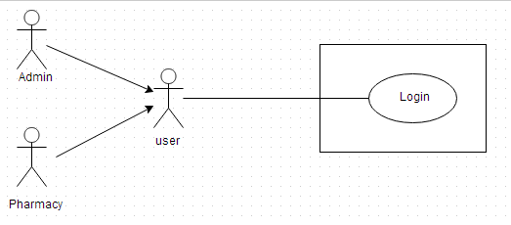

Use-case Specification

UC016-01: <Admin> Login

UC016 - Specification
Use-case No. | <UC016> | Use-case Version |  | <1.0>
Use-case Name | <Admin> Login
Author | Thu NH
Date | 22/05/2013 | Priority | <High >
Actor:
Administrator
Summary:
When Administrator want to do their system controlling work, they must access to system by the username and password that has been set role as admin
Goal:
Administrator can log into system successful
Triggers
User input username and password correctly in the right text box then click “Login” button
Preconditions:
User must have username and password that has been set role as admin to access to system
Post Conditions:
User can login successfully as Administrator
Main Success Scenario:
Step | User | System
1 | Click on “Login” hyperlink on the right top corner | Displays a pop up for Administrator fill their User Name and Password
2 | Fill right User Name and Password | The system validates the input data
3 | Click “Login” button | Close the pop up and log into system as an Administrator user

Alternative Scenario:
At step | User | System
3 | Click on Close icon of the pop up | Close the pop up and do not log into system

Exceptions:
At Step | User | System
2 | Fill wrong User Name or Password | The system validates the input data
3 | Click on “Login” button | Return Error message

Business Rule:
- Username must be input as email full format
- Password must be longer than 8 characters

UC016-02: <Pharmacy user> Login

UC016-02 - Specification
Use-case No. | <UC0016> | Use-case Version |  | <1.0>
Use-case Name | <Pharmacy user> Login
Author | Thu NH
Date | 22/05/2013 | Priority | <High >
Actor:
Pharmacy user
Summary:
When pharmacy user wants to log into system to control their data information, they must have username and password that has been set role as pharmacy user to login
Goal:
User can log into system successful
Triggers
User input username and password correctly in the right text box then click on “Login” button
Preconditions:
User must have username and password that has been set role as pharmacy user
Post Conditions:
User can login as Pharmacy user and system displays user’s information management screen
Main Success Scenario:
Step | User | System
1 | Click on “Login” tab | Displays a pop up for user fill their User Name and Password
2 | Fill right User Name and Password | The system validates the input data
3 | Click “Login” button | Close the pop up and log into system as a Pharmacy user. Display user information management screen

Alternative Scenario:
At Step | User | System
3 | Click on Close icon of the pop up | Close the pop up and do not log into system

Exceptions:
At Step | User | System
2 | Fill wrong User Name or Password
3 | Click on “Login” button | Return Error message

Business rule:
- Username must be input as email full format
- Password must be longer than 8 characters

UC017: Log out

Use Case Diagram

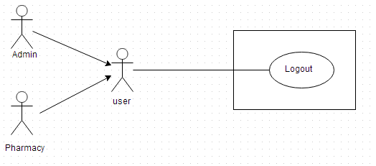

Use-case Specification

UC017 - Specification
Use-case No. | <UC017> | Use-case Version |  | <1.0>
Use-case Name | Log out
Author | Thu NH
Date | 22/05/2013 | Priority | <High >
Actor:
Administrator and Pharmacy user
Summary:
When users want to finish their system controlling work, they must log out system by click into hyperlink in the right top corner of screen
Goal:
Users can log out system successful
Triggers
Click on “Log out” hyperlink on right top corner of the page
Preconditions:
User has logged in successfully
Post Conditions:
Users logout system completely
Main Success Scenario:
Step | User | System
1 | Have logged into system
2 | Click on “Log out” link on right top corner of the page | Displays a pop up to confirm if they really want to log out
3 | Click “Yes” button | Close the pop up and log out system
Alternative Scenario:
At Step | User | System
3 | Click “Close” icon of the pop up | Close the pop up and do not log out system

Exceptions:
At Step | User | System
3 | Click “Cancel” button | Close the pop up and do not log out system

Manage pharmacy information

Use Case Diagram

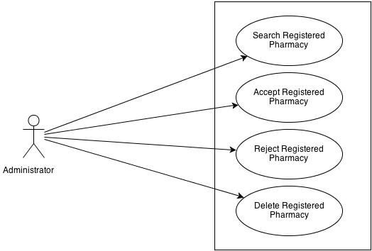

Use-case Specification

UC0018: <Admin> Search Registered Pharmacy

UC018 - Specification
Use-case No. | <UC0018> | Use-case Version |  | <1.0>
Use-case Name | <Admin> Search registered pharmacy
Author | Thu NH
Date | 22/05/2013 | Priority | <High >
Actor:
Admin
Summary:
When Administrator want to look for registered pharmacy information, they have the separate search screen to control pharmacy user data
Goal:
Administrator can search pharmacy information successfully if it has been registered
Triggers
Click on “Management/ Pharmacy manage” tab, fill pharmacy name into text box then click “Search” button
Preconditions:
Input data must be correctly and User has to login as Administrator user
Post Conditions:
System must have data of searched pharmacy and can displays detail information of that pharmacy
Main Success Scenario:
Step | User | System
1 | Have logged into system as an admin
2 | Click on “Management/ Pharmacy manage” tab | Displays criteria search screen
3 | Fill the name of the pharmacy that they want to find into these fields then click “Search” button | Displays search result as a table
4 | Click on that pharmacy name | Display “Pharmacy information” screen that contains the information of chosen pharmacy with these elements:  - Pharmacy name  - Representative  - Phone  - Email  - Address
Alternative Scenario:
At Step | User | System
3 | Fill the name of the pharmacy that they want to find into these fields then click on another link | Switch to selected page

Exceptions:
At Step | User | System
3 | Fill the name of the pharmacy that they want to find into these fields (that pharmacy has not registered) then click “Search” button | Return Error message to inform that pharmacy cannot be found

UC0019: <Admin> Accept Registered Pharmacy

UC019 - Specification
Use-case No. | <UC0019> | Use-case Version |  | <1.0>
Use-case Name | <Admin> Accept registered pharmacy
Author | Thu NH
Date | 22/05/2013 | Priority | <High >
Actor:
Admin
Summary:
When Administrator want to accept for registered pharmacy displays their information on the system
Goal:
Pharmacy can register successfully into system
Triggers
Click on “Management/ Pharmacy management” tab then search for a pharmacy then tick the check box beside that pharmacy name and click on “Accept” button
Preconditions:
Input data must be correctly and User has to login as Administrator user
Post Conditions:
Registered pharmacy has been accepted
Main Success Scenario:
Step | User | System
1 | Have logged into system as an admin
2 | Click on “Management/ Pharmacy management” tab | Displays criteria search screen
3 | Fill the name of the pharmacy that they want to find into these fields then click “Search” button | Displays search result as a table
4 | Tick on check box beside the pharmacies that they want to accept
5 | Click Accept button | Accept these registered pharmacies to have permission to promote their information on that software

Alternative Scenario:
At Step | User | System
5 | Click on another link | Switch to selected page. These selected pharmacy has not been accepted
Reference:
UC018 - <Admin> Search Registered Pharmacy

UC020: <Admin> Delete Registered Pharmacy

UC020 - Specification
Use-case No. | <UC0020> | Use-case Version |  | <1.0>
Use-case Name | <Admin> Delete registered pharmacy
Author | Thu NH
Date | 22/05/2013 | Priority | <High >
Actor:
Admin
Summary:
When Administrator want to delete registered pharmacy from the system
Goal:
Pharmacy cannot register into system
Triggers
Click on “Management/ Pharmacy management” tab then search for a pharmacy then tick the check box beside that pharmacy name and click on “Delete” button
Preconditions:
Input data must be correctly and User has to login as Administrator user
Post Conditions:
Registered pharmacy has been deleted
Main Success Scenario:
Step | User | System
1 | Have logged into system as an admin
2 | Click on “Pharmacy/ Pharmacy management” tab | Displays criteria search screen
3 | Fill the name of the pharmacy that they want to find into these fields then click “Search” button | Displays search result as a table
4 | Tick on text box beside the pharmacies that they want to delete
5 | Click Delete button | Delete these pharmacy from system then they do not have permission to promote their information on that software anymore

Alternative Scenario:
At Step | User | System
5 | Click on another link | Switch to selected page. These selected pharmacy has not been deleted
Reference:
UC018 - <Admin> Search Registered Pharmacy

Manage medicine information

Use Case Diagram
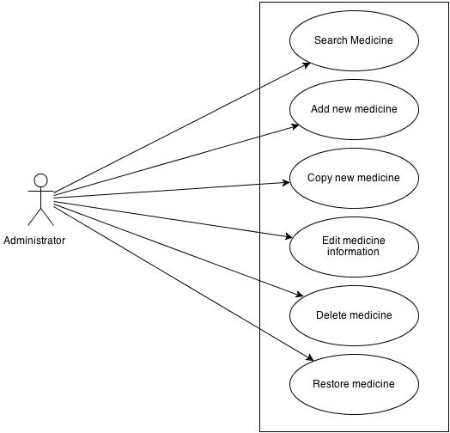

User Case Specification

UC021: <Admin> Search medicine

UC021 - Specification
Use-case No. | <UC0021> | Use-case Version |  | <1.0>
Use-case Name | <Admin> Search medicine
Author | Thu NH
Date | 22/05/2013 | Priority | <High >
Actor:
Admin
Summary:
When Administrator want to search a medicine on database
Goal:
Administrator can search medicine information in database successfully if it is existed
Triggers
Click on “Management/ Medicine management” tab, input medicine information in the right text box then click “Search” button
Preconditions:
Input data must be correctly and User has to login as Administrator user
Post Conditions:
Displays medicine detail information
Main Success Scenario:
Step | User | System
1 | Have logged into system as an admin
2 | Click on “Medicine/ Medicine Advanced Search ” tab | Displays criteria search screen
3 | Fill information of the medicine that they want to find into these fields then click “Search” button | Displays search result as a table
4 | Click on that medicine name | Display “Medicine information” screen that contains the information of chosen medicine with these elements:  - Medicine name  - Contraindicated  - Dosing and Using  - Ingredient  - Manufacture  - Package

Alternative Scenario:
At Step | User | System
3 | Fill information of the medicine that they want to find into these fields then click on another link | Switch to selected page

Exceptions:
At Step | User | System
3 | Fill information of the medicine that they want to find (that do not exited in database) into these fields then click “Search” button | Return Error message to inform that medicine cannot be found

UC022: <Admin> Add New medicine

UC022 - Specification
Use-case No. | <UC0022> | Use-case Version |  | <1.0>
Use-case Name | <Admin> Add new medicine
Author | Thu NH
Date | 22/05/2013 | Priority | <High >
Actor:
Admin
Summary:
When Administrator want to add a medicine into database. They have to insert all necessary data of medicine into “Medicine add new” screen
Goal:
Administrator can add new medicine information in database successfully
Triggers
User must click on “Medicine/ Add new” tab and input all necessary information of medicine into the right fields then click on “Save” button
Preconditions:
- User have logged into system as an admin.
- All mandatory fields have been filled
- All input data must be valid and have not existed in system
Post Conditions:
New medicine has been saved into system database successfully
Main Success Scenario:
Step | User | System
1 | Have logged into system as an admin
2 | Click on “Medicine/ Add new” tab | Display “Add New” screen that contains these elements:  - Medicine name  - Contraindicated  - Dosing and Using  - Ingredient  - Manufacture  - Package
3 | Fill medicine information into all necessary or mandatory fields
4 | Click “Save” button | The system validates the input data and then save new medicine data into database

Alternative Scenario:
At Step | User | System
4 | Click on another link | Do not save new medicine data into database then redirect to selected page

Exceptions:
At Step | User | System
4 | Click “Save” button | Return Error message beside invalid value and do not save data into database

UC023: <Admin> Copy New medicine

UC023 - Specification
Use-case No. | <UC0023> | Use-case Version |  | <1.0>
Use-case Name | <Admin> Copy new medicine
Author | Thu NH
Date | 22/05/2013 | Priority | <High >
Actor:
Admin
Summary:
When Administrator want to add a medicine on database which has some similar information to an existed medicine
Goal:
Administrator can add new medicine information in database successfully
Triggers
User must click on “Medicine/ Medicine Advanced Search ” then search for the medicine that they want to copy and amend necessary information of medicine in the right fields then click on “Save” button
Preconditions:
- User have logged into system as an admin.
- All mandatory fields have been filled
- All input data must be valid and have not existed in system
Post Conditions:
New medicine has been saved into system database successfully
Main Success Scenario:
Step | User | System
1 | Have logged into system as an admin
2 | Click on “Medicine/ Medicine Advanced Search ” then search for the medicine that they want to copy | Displays search result as a table
3 | Click on “Copy New” button beside that medicine row | Display “Add New” screen that contains the information of chosen medicine with these elements:  - Medicine name  - Contraindicated  - Dosing and Using  - Ingredient  - Manufacture  - Package
4 | Edit medicine information
5 | Click “Save” button | The system validates the input data and then save data into database

Alternative Scenario:
At Step | User | System
4 | Edit medicine information then click to another link | Do not save edited data then redirect to selected page

Exceptions:
At Step | User | System
4 | Edit medicine information to be similar to another existed medicine
5 | Click “Save” button | The system validates the input data and return Error message and do not save edited data into database
Reference:
UC021 - <Admin> Search Medicine

UC024: <Admin> Edit medicine

UC024 - Specification
Use-case No. | <UC0024> | Use-case Version |  | <1.0>
Use-case Name | <Admin> Edit medicine
Author | Thu NH
Date | 22/05/2013 | Priority | <High >
Actor:
Admin
Summary:
When Administrator want to edit a medicine on database
Goal:
Administrator can change that medicine information in database successfully
Triggers
User must click on “Medicine/ Medicine Advanced Search ” then search for the medicine that they want to edit and amend necessary information of medicine in the right fields then click on “Save” button
Preconditions:
- User have logged into system as an admin.
- All mandatory fields have been filled
- All input data must be valid and have existed in system
Post Conditions:
Changed information of medicine has been saved into system database successfully
Main Success Scenario:
Step | User | System
1 | Have logged into system as an admin
2 | Click on “Medicine/ Medicine Advanced Search ” then search for the medicine that they want to edit | Displays search result as a table
3 | Click on Edit button beside that medicine row | Display “Medicine information” screen that contains the information of that medicine with these elements:  - Medicine name  - Contraindicated  - Dosing and Using  - Ingredient  - Manufacture  - Package
4 | Edit medicine information
5 | Click “Save” button | The system validates the input data and then save edited data into database

Alternative Scenario:
At Step | User | System
4 | Edit medicine information then click to another link | Do not save edited data then redirect to selected page

Exceptions:
At Step | User | System
4 | Edit medicine information to be similar to another existed medicine
5 | Click “Save” button | The system validates the input data and then return Error message and do not save edited data into database
Reference:
UC0021 - <Admin> Search Medicine

UC025: <Admin> Delete medicine

UC025 - Specification
Use-case No. | <UC0025> | Use-case Version |  | <1.0>
Use-case Name | <Admin> Delete medicine
Author | Thu NH
Date | 22/05/2013 | Priority | <High >
Actor:
Admin
Summary:
When Administrator want to delete a medicine on database
Goal:
Administrator can change that medicine’s delete flag to “1”in database successfully
Triggers
User must click on “Medicine/ Medicine Advanced Search ” then search for the medicine that they want to delete and tick on check box beside medicine name then click on “Delete” button
Preconditions:
- User have logged into system as an admin.
- All mandatory fields have been filled
- All input data must be valid and have existed in system
Post Conditions:
Medicine has been deleted from system database successfully
Main Success Scenario:
Step | User | System
1 | Have logged into system as an admin
2 | Click on “Medicine/ Medicine Advanced Search ” then search for the medicine that they want to edit | Displays search result as a table
3 | Click on “Delete” button beside that medicine row | Displays pop up to confirm if they really want to remove that medicine
4 | Click “Yes” button on popup | Closes the popup then remove that medicine name from medicine list

Alternative Scenario:
At Step | User | System
4 | Click close icon of the popup | Only closes the popup, does not remove that medicine

Exceptions:
At Step | User | System
4 | Click “Cancel” button on popup | Only closes the popup, does not remove that medicine
Reference:
UC021 - <Admin> Search Medicine

UC026: <Admin> Restore medicine

UC026 - Specification
Use-case No. | <UC0026> | Use-case Version |  | <1.0>
Use-case Name | <Admin> Restore medicine
Author | Thu NH
Date | 22/05/2013 | Priority | <High >
Actor:
Admin
Summary:
When Administrator want to restore a deleted medicine on database
Goal:
Administrator can change that medicine’s delete flag to “0”in database successfully
Triggers
User must click on “Medicine/ Medicine Advanced Search”. Tick on “Deleted” check box then search for the medicine that they want to restore and tick on check box beside medicine name then click on “Restore” button
Preconditions:
- User have logged into system as an admin.
- All mandatory fields have been filled
- All input data must be valid and have been deleted from system
Post Conditions:
Deleted medicine has been restored in system database successfully
Main Success Scenario:
Step | User | System
1 | Have logged into system as an admin
2 | Click on “Medicine/ Medicine Advanced Search ” tab | Displays “Medicine Advanced Search” page
3 | Tick on Delete flag then search for the medicine that they want to edit | Displays search result as a table
3 | Click on “Restore” button beside that medicine row | Displays pop up to confirm if they really want to restore that medicine
4 | Click “Yes” button on popup | Closes the popup then restore that medicine name in medicine list

Alternative Scenario:
At Step | User | System
4 | Click close icon of the popup | Only closes the popup, does not remove that medicine

Exceptions:
At Step | User | System
4 | Click “Cancel” button on popup | Only closes the popup, does not remove that medicine
Business Rule:
Medicine can only be restored if there is no similarly medicine existed
Reference:
UC0025 - <Admin> Delete medicine

Account control

Use Case Diagram

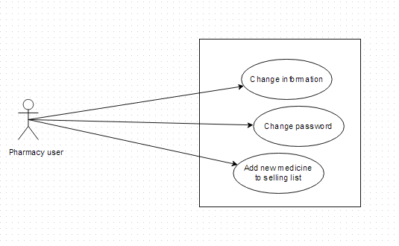

Use-case Specification

UC027: <Pharmacy user> Change Information

UC027 - Specification
Use-case No. | <UC0027> | Use-case Version |  | <1.0>
Use-case Name | <Pharmacy user> Change information
Author | Thu NH
Date | 22/05/2013 | Priority | <High >
Actor:
Pharmacy user
Summary:
When user want to change their registered information
Goal:
User can change the information that have permission to change
Triggers
Click on User name link on right top corner of page. System displays User information screen. Click on “Change information” button then amend information. Click “Save” button
Preconditions:
All mandatory fields must be filled and User have logged into system as a pharmacy user
Post Conditions:
The new information has been saved successfully
Main Success Scenario:
Step | User | System
1 | Have logged into system as an user
2 | Click on User name link on right top corner of page | Displays User information screen
3 | Click on “Change information” button | Display Change information screen
4 | Type new information into text fields (validate)
5 | Click on “Save” button | The system validates the input data and then save new information into database
Exceptions:
At Step | User | System
4 | Type new information into text fields (invalidate)
5 | Click on “Save” button | The system validates the input data and then displays error message beside wrong fields

UC028: <Pharmacy user> Change password

UC028 - Specification
Use-case No. | <UC0028> | Use-case Version |  | <1.0>
Use-case Name | <Pharmacy user> Change password
Author | Thu NH
Date | 22/05/2013 | Priority | <High >
Actor:
Pharmacy user
Summary:
When user want to change their register password or when they forgot their password, they can offer to a new one right after access to login feature
Goal:
User can change their password successfully
Triggers
1. User has accessed to SMD website. Click on “Login” tab then click on “Do not remember password”. Insert their registered email then click “Send” button
2. User login to system then click on “Change password” link on the right top corner of the page. Insert current password then insert new password that is validate then click “Save” button
Preconditions:
- Users have to remember their registered email
- If user change password after login, new password must be valid
Post Conditions:
Password has been changed successfully
Main Success Scenario:
Step | User | System
1 | Have logged into system as an user
2 | Click on “Change password” link on the right top corner of the page | Switches to “Change password” page
3 | Insert current password then insert new password that is validate | The system validates the input data
4 | Click “Finish” button | Display successful page with message to inform user that new password can be used after being confirm by admin

Alternative Scenario:
At Step | User | System
1 | Click on “Login” hyperlink on the right top corner
2 | Click on “Forget password” link | Switches to “Change password” page
3 | Insert their registered email then click “Send” button | The system validates the input data and sends new password to that email
4 | Use that new email to login system | Login successfully

Exceptions:
At Step | User | System
1 | Have logged into system as an user
2 | Click on “Change password” link on the right top corner of the page | Switches to “Change password” page
3 | Insert current password then insert new password that is invalid | The system validates the input data and then displays error message beside wrong value
4 | Click “Finish” button | Displays successful page with message to inform user that new password can be used after being confirm by admin

UC029: <Pharmacy user> Add new medicine into pharmacy’s sell list

UC0029 - Specification
Use-case No. | <UC0029> | Use-case Version |  | <1.0>
Use-case Name | <Pharmacy user> Add new medicine into pharmacy’s selling list
Author | Thu NH
Date | 22/05/2013 | Priority | <High >
Actor:
Pharmacy user
Summary:
When user want to add a new medicine into their selling list, they can control their selling list right in their manage information tab
Goal:
User can add medicine information into database
Triggers
After login system, user click on “Manage” tab on submenu then click on “Selling list” tab and click on “Add new” button. User search for a medicine then tick on check box beside it and click on “Add” button
Preconditions:
- Medicine in selling list must have data information in SMD system
- User have logged into system as a pharmacy user
Post Conditions:
Medicine can be added into pharmacy selling list successfully
Main Success Scenario:
Step | User | System
1 | Have logged into system as a pharmacy user
2 | Click on Manage tab on submenu | Display Manage screen with representative information and pharmacy list of that user
3 | Click on one pharmacy name | Display screen with 2 tabs: Pharmacy information and “Selling list”
4 | Click on “Selling list” tab | Display screen that is similar to advanced search screen to look for list of medicine which are selling in that pharmacy. On the bottom of screen, there is “add new” button
5 | Click on “Add new” button | Display new screen with 2 tabs: Search medicine, add new
6 | Click on Search medicine | Display tab content that has similar format to Quick search screen to look for the existed medicine on system
7 | Search for the medicine that need to be added. Tick on the check box beside it then click on “Add” button | Add that medicine name into Selling list of that pharmacy

Alternative Scenario:
At Step | User | System
6 | Click on “Add new” tab | Display Add new screen that has similar format to admin’s screen
7 | Fill all necessary information then click “Save” button | The system validates the input data and then save that medicine information into database and add its name into Selling list of that pharmacy

Exception:
At Step | User | System
6 | Click on “Search medicine” tab | Display the screen that have similar format to Quick search screen
7 | Search for the medicine that need to be added (That medicine name does not exist in database) | Return warning message that data not found and display “Add brand new” button
Reference:
UC005 - Quick search
UC016 - <Admin> Add new medicine

Non-functional Specification

User interface
a. Arrangement
SDM will have 4 areas: Banner, Submenu, Content, Contact and information
- The banner will display on the top of the page and contain: SDM icon and name of the program
- Elements in Submenu will change as role of user
- Content displays below submenu and change interface as feature users have chosen
- Contact and information will display on the bottom of page and contain necessary information to help user to contact administrators in need
b. Color
The system has been designed to use less and simple color to make the page be fresh and clearly to user. Users can easily notice what they want
c. Text
All text bases on Tahoma style. Their size and font style will rely on their type, their function. The text style will be divided into some specific types to make the website be unified

Hardware Requirements
All data and applications installed at the servers, so it should be required the best equipment. When equipped servers, it is necessary to pay attention to the following element:
- Configuration suggestions:
# | Name | Configuration | Description
1 | Application Server | RAM: 2GB  Hard disk: 150GB  Chipset: Core 2 Dual 2.0 GHz | Server for application server to deploy web application with the minimum configuration
2 | Client | RAM:2GB  Hard disk: 150GB  Chipset: Core 2 Dual 2.0 GHz | Notebooks for developing/testing with the minimum configuration
3 | Mobile device | RAM: 1 GB  Hard disk: 32GB  Chip 1.5GHz Core 4-PLUS-1 Quad | Mobile installed application with configuration

- Configured transmission line: Depending on the actual topography of each deployment environment that function setting up the network will be able to use copper cable, optical cable or wireless.

Software Requirements
Software name | Version | Source
Firefox | 20 | Mozilla
Chrome | 25 | Google
Android | Upper from 2.3 | Google
Operating System: Microsoft® Windows 7 | 2007 | Microsoft
.Net Framework | 4.0 | Microsoft( used to setup MySQL)
DBMS: MySQL Workbench | 5.6.11.0 | Oracle
IDE: Eclipse Indigo | indigo-SR1-win32 | Eclipse
Strut | 2 | Apache
Spring | 3 | Spring
Hibernate | 3 | Hibernate
Table 4-1: Software requirement

Reliability
- The database must be backed up daily and can be recovered if necessary
- Mean time between failures (MTBF): The mean time between each failure is expected to be about 480 hours (20 days) of using.
- Mean time to repair (MTTR): Immediately when Administrator finds out problem or website is attacked by someone. Average 1 day.
- The maximum bugs per function are 2 bugs/a function when user uses software within 2 months. The average number of bugs in the software during system testing is about to be around 0.5 bugs/1000LOC.
Bug | Definition
Minor | Bugs related to GUI
Significant | Bugs related to minor business logic
Critical | Function can’t execute correctly, completely loss of data, disconnect to the server
Table 4.1 – Bugs or Defect Rate

Availability
The available time is approximately 99% and must be available 24 hours a day, 7 days a week, besides user must have the ability to access website by any web browser in his or her computers or mobile devices.

Security
In order to avoid unwanted access by strangers, the security implemented in various ways:
- User layer: Each pharmacy representative must be distributed system access and manipulate the individual parts. To edit information, user must declare their usename and password before the operation. Functions will be shown after users login dependencies user’s role and permission of each user.
- Manage Data Layer: Only Administrator can modify database system.
- Stored Data: All data about information of user, medicine, pharmacy, and news will be saved in My SQL Server, and be easy for data classification or backup.

Maintainability
- Coding standards and naming conventions
  - Output of the project must include coding standards and naming conventions documentations. Implementation code must be easy to maintain.
  - All code must be clearly commented, including class, method documentations.
  - If some components are reused, the documentations of those components must also be included.
- Design
  - The design of the system must be loosely coupled that chances on some module will not affect others.
- Logging
  - All the errors should be logged, supporting for bug fixing and maintenance.
  - All strange or sensitive situations should also be logged.

Portability
- Website can be deployed on Windows.
- Mobile version can be used in all devices which run on Android version 2.3 or higher

Performance
In term of response time, the maximum time for accessing any page will be 2 to 5 seconds when the processing of search function will not exceed 5 seconds. However, it also depends on the internet bandwidth the network coverage‘s condition.
The internet band width is 10 GB/month
The configuration of application servers and clients meets the defined requirements in section 4.4.2.
And the are about 100,000 medicines and 20,000 pharmacy in database.

Entity Relationship Diagram or Data Structures

Entity Relationship Diagram
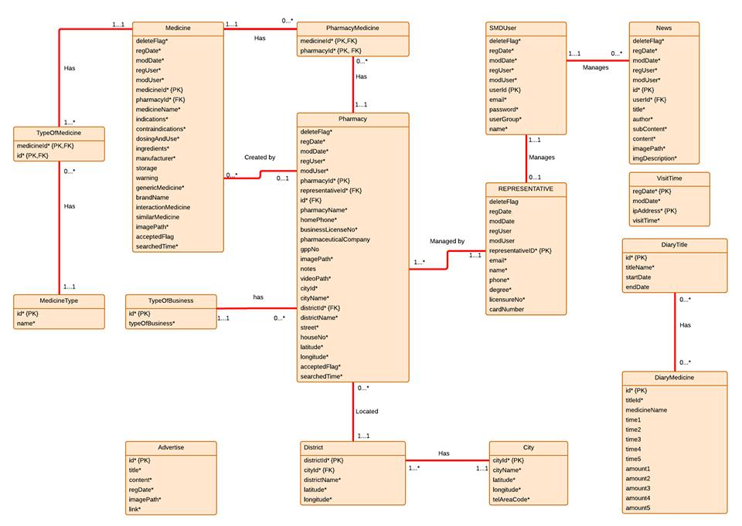
Figure 4-2: Entity relationship diagram

Entity Detail

Medicine
Attribute | Type | Mandatory | Description
Medicine ID | Number | PK, Y | The primary key auto generated by the system
Delete Flag | String | Y | Marked deleted
Register Date | Date | Y | Date register medicine
Modify Date | Date | Y | Date modify medicine
Register User | String | Y | User register medicine
Modify User | String | N | User modify medicine
Pharmacy ID | Number | Y (FK) | Number of pharmacy
Name | String | Y | Name of medicine
Indications | String | Y | Indication of medicine
Contraindications | String | Y | Contraindications of medicine
Dosing And Use | String | Y | Dosing and use of medicine
Ingredients | String | Y | Ingredients of medicine
Manufacturer | String | Y | Manufacturer of medicine
TypeOfPackageID | Number | Y | Type of package id of medicine
TypeOfPackageName | String | Y | Type of package name of medicine
Storage | String | N | Storage medicine
Warning | String | N | Warning of medicine
Generic Drug | String | N | Name generic of medicine
Brand Name | String | N | Brand name of medicine
Interaction Medicine | String | N | Interaction of medicine
Similar Medicine | String | N | Name of similar medicine
Image Path | String | Y | Path to image of medicine
Accepted Flag | String | N | Marked accepted
Search Time | String | N | Time to search

Pharmacy
Attribute | Type | Mandatory | Description
Pharmacy ID | Number | PK, Y | The primary key auto generated by the system
Delete Flag | String | Y | Marked deleted
Register Date | Date | Y | Date register medicine
Modify Date | Date | Y | Date modify medicine
Register User | String | Y | User register medicine
Modify User | String | N | User modify medicine
Name | String | Y | Name of pharmacy
Home Phone | Number | Y | Home phone number of pharmacy
Business License No | String | Y | Number business license of pharmacy
Pharmaceutical Company | String | N | Name of pharmaceutical company
Gpp No | String | N | Number of GPP
Notes | String | N | Notes about pharmacy
Money | String | N | Money of pharmacy
Image Path | String | Y | Path to image of pharmacy
Video Path | String | Y | Path to video of pharmacy
Representative ID | Number | Y | ID of representative
City | String | Y | City of pharmacy
District | String | Y | District of pharmacy
City ID | Number | Y | ID of city
District ID | Number | Y | ID of district
Street | String | Y | Street of pharmacy
House No | String | Y | Number house of pharmacy
Latitude | String | N | Latitude of pharmacy
Longitude | String | N | Longitude of pharmacy
Accepted Flag | String | N | Marked accepted
Searched Time | String | N | Time to search
TypeOfBusinessName | String | Y | Name of type business

PharmacyMedicine
Attribute | Type | Mandatory | Description
Pharmacy ID | Number | Y | ID of pharmacy
Medicine ID | Number | Y | ID of medicine

SMD User
Attribute | Type | Mandatory | Description
Delete Flag | String | Y | Marked deleted
Register Date | Date | Y | Date register medicine
Modify Date | Date | Y | Date modify medicine
Register User | String | Y | User register medicine
Modify User | String | N | User modify medicine
Email | String | Y | Email of User
Password | String | Y | Password of User
User Group | String | Y | Group of User

Representative
Attribute | Type | Mandatory | Description
Delete Flag | String | Y | Marked deleted
Register Date | Date | Y | Date register medicine
Modify Date | Date | Y | Date modify medicine
Register User | String | Y | User register medicine
Modify User | String | N | User modify medicine
Representative ID | Number | Y | Id of representative
Email | String | Y | Email of representative
Name | String | Y | Name of representative
Phone | Number | Y | Phone of representative
Degree | String | Y | Degree of representative
Licensure No | Number | Y | Licensure number of representative
Card Number | String | Y | Number card of representative

Medicine Type
Attribute | Type | Mandatory | Description
ID | Number | Y | Id of medicine type
Name | String | Y | Name of medicine type

City
Attribute | Type | Mandatory | Description
City ID | Number | Y | Id of City
City Name | String | Y | Name of city
Latitude | String | Y | Latitude of city
Longitude | String | Y | Longitude of city
Tel area code | String | y | Tel area code of city

District
Attribute | Type | Mandatory | Description
District ID | Number | Y | Id of District
District Name | String | Y | Name of District
Latitude | String | Y | Latitude of district
Longitude | String | Y | Longitude of district
City ID | Number | Y | ID of City

News
Attribute | Type | Mandatory | Description
Delete Flag | String | Y | Marked deleted
Register Date | Date | Y | Date register medicine
Modify Date | Date | Y | Date modify medicine
Register User | String | Y | User register medicine
Modify User | String | N | User modify medicine
News ID | Number | Y | Id of News
Title | String | Y | Title of News
Content | String | Y | Content of News
Image Path | String | Y | Path to image of News
Video Path | String | Y | Path to video of News

Type Of Business
Attribute | Type | Mandatory | Description
ID | Number | Y | ID of type
Type Of Business | String | Y | Type of business

Visit Time
Attribute | Type | Mandatory | Description
Register Date | Date | Y | Date register
Modify Date | Date | Y | Date modify
IP Address | String | Y | IP of address
Visit Time | String | Y | Time to visit

Diary Title
Attribute | Type | Mandatory | Description
ID | Number | Y | ID of diary
Title Name | String | Y | Name of title diary
Start Date | Date | N | Start Date of diary
End Date | Date | N | End Date of diary

Diary Medicine
Attribute | Type | Mandatory | Description
Medicine ID | Number | Y | ID of medicine
Title ID | Number | Y | ID of title
Time1 | String | N | Time use medicine
Time2 | String | N | Time use medicine
Time3 | String | N | Time use medicine
Time4 | String | N | Time use medicine
Time5 | String | N | Time use medicine
Amount1 | String | N | Amount medicine to use
Amount2 | String | N | Amount medicine to use
Amount3 | String | N | Amount medicine to use
Amount4 | String | N | Amount medicine to use
Amount5 | String | N | Amount medicine to use

